**SMART Delivery Document Application Flow v. 1.0**

This application easily searches and updates details of delivery documents dispatched to the clients and returned to the office. The application’s ‘database’ is a set of Cycle Filenames stored in a specified directory at the root directory (currently it is **C:\SMARTFOLDER**). A cycle filename contains all delivery documents to be sent out to the clients thru a messenger. The application should be able to track all outgoing and incoming delivery documents, including the status of each delivery document. This application does not need to extract the newly updated cycle filename, because the application directly writes and reads from these cycle filenames. The cycle filenames should be in **.XLS** format.

The first thing to be done before using the application is to have it installed in your local machine (laptop, PCs, etc.). At default, when the installer successfully installs the application, it will create an icon at the desktop, create a shortcut at the programs menu at the task bar and installs itself to the application directory. Both the desktop icon and the program icon at the task bar points to the application directory.

Now, to start the application, click its icon (more conveniently from the desktop) and the application will run.

1. **Running the application.**

When you run the application, the application shows up as shown in the figure below:

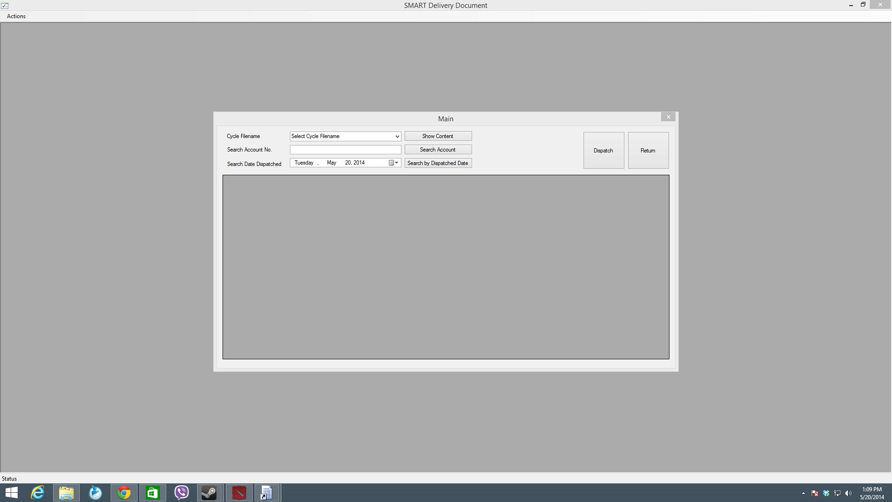

The main window is shown here, showing the following:

1. **SHOW/SEARCH BY**
   1. Show by Cycle filename
   2. Search by Account No.
   3. Search by Date Dispatched
2. **BUTTON LAUNCH**
   1. Dispatch Button
   2. Return Button
3. **Show Content by Cycle Filename**

To show the content of the cycle filename, you have to choose first the Cycle filename from the combo box that has a label **“Select Cycle Filename”.** The picture below shows that a cycle filename is in the process of being selected.

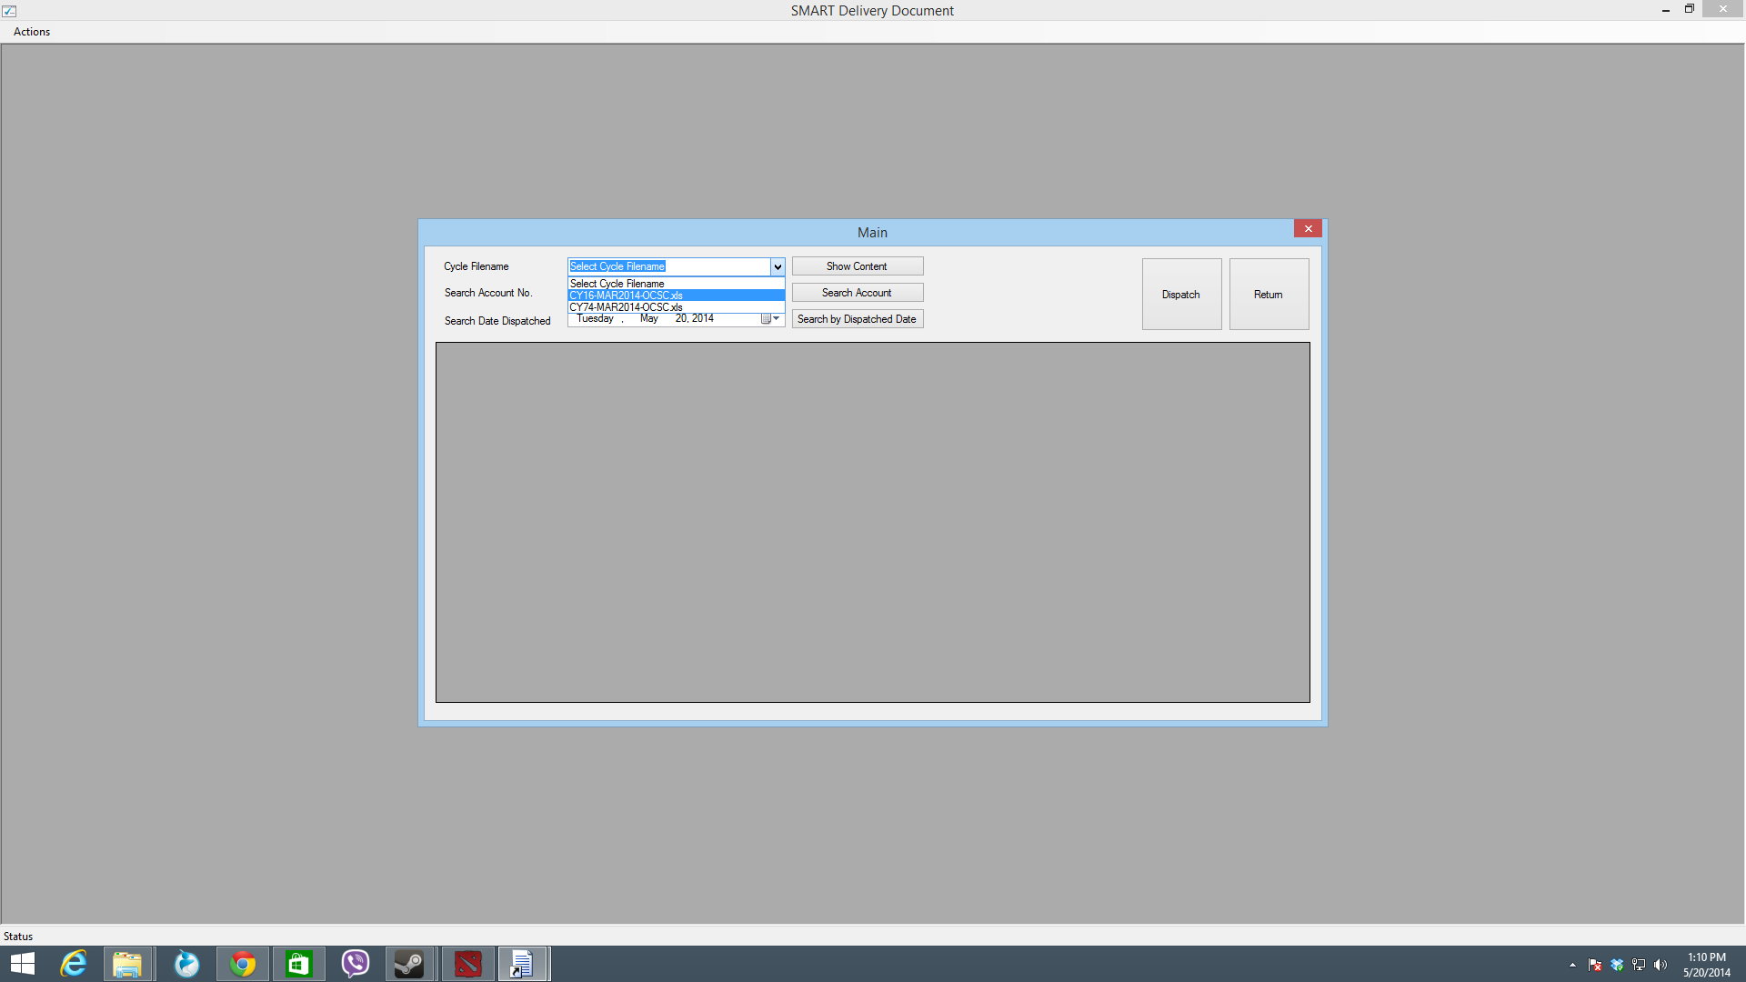

Once the cycle filename is selected, click the **Show Content** button. It should show the contents of the selected cycle filename. Below is a sample content of a selected filename:

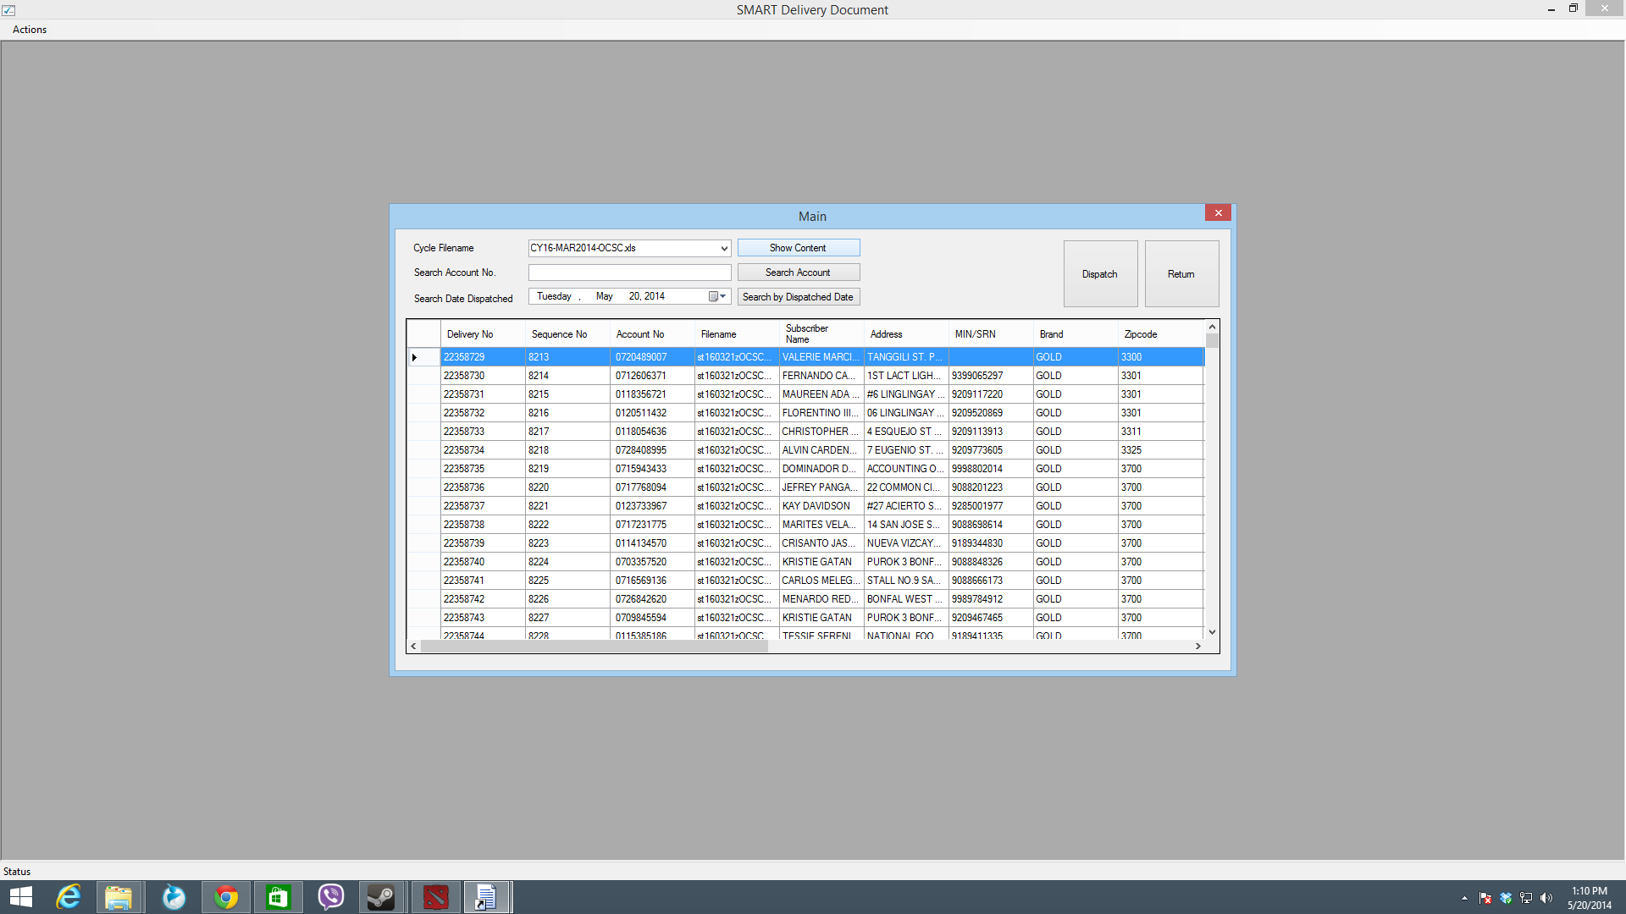

1. **Search by Account No.**

Searching for an account number is the same as showing the content of the cycle filename. However, it only shows a particular account from the content of the cycle filename, given it account no. To search for an account, key-in the account number in the **Search Account No** textbox. Make sure that a cycle file is selected before searching for a particular account. The image below shows that an account no is being keyed-in to the text:

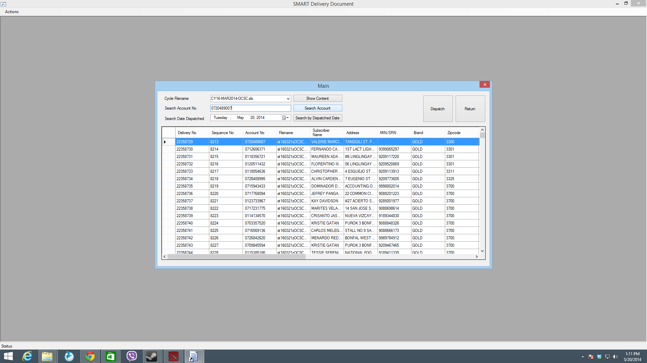

After having typed the account no, press the **Search Account** button. This will show the particular account record for that selected cycle filename. Picture below shows that an account is found, for a selected cycle filename:

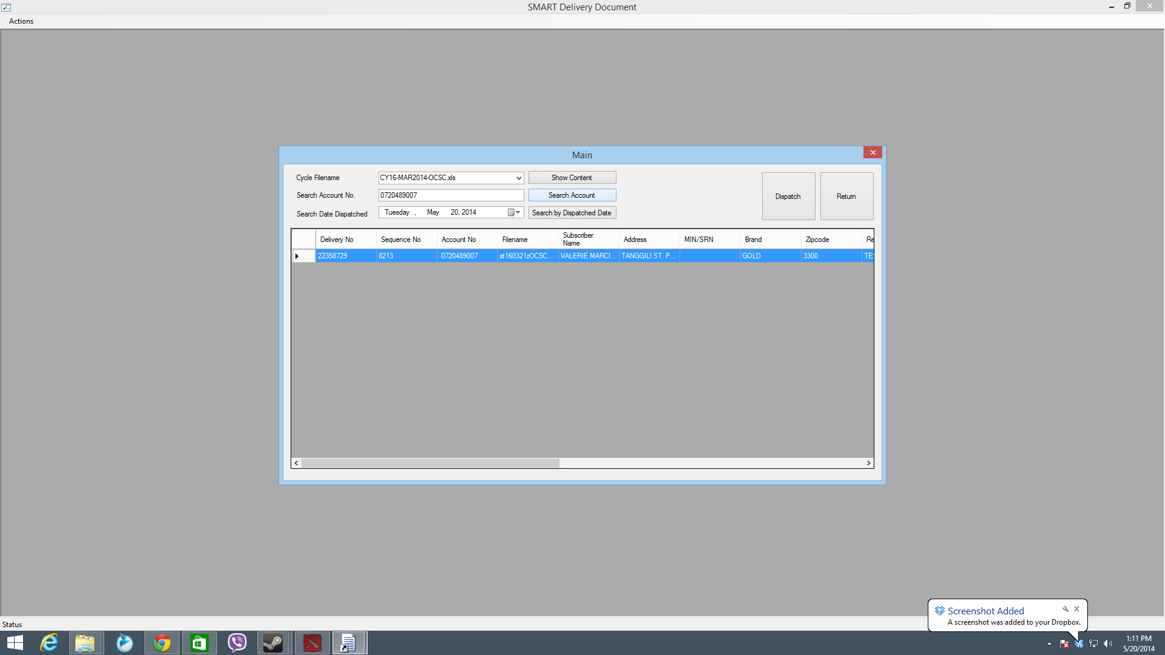

1. **Search by Dispatch Date**

To know all the accounts that have been dispatched for a specific day, you need to search the cycle filename by the dispatch date of the delivery document. Simply select a particular date on the **Search Date Dispatched** date picker. Before, searching by dispatch date, it is required to select first the cycle filename. Image below shows that a date has been selected:

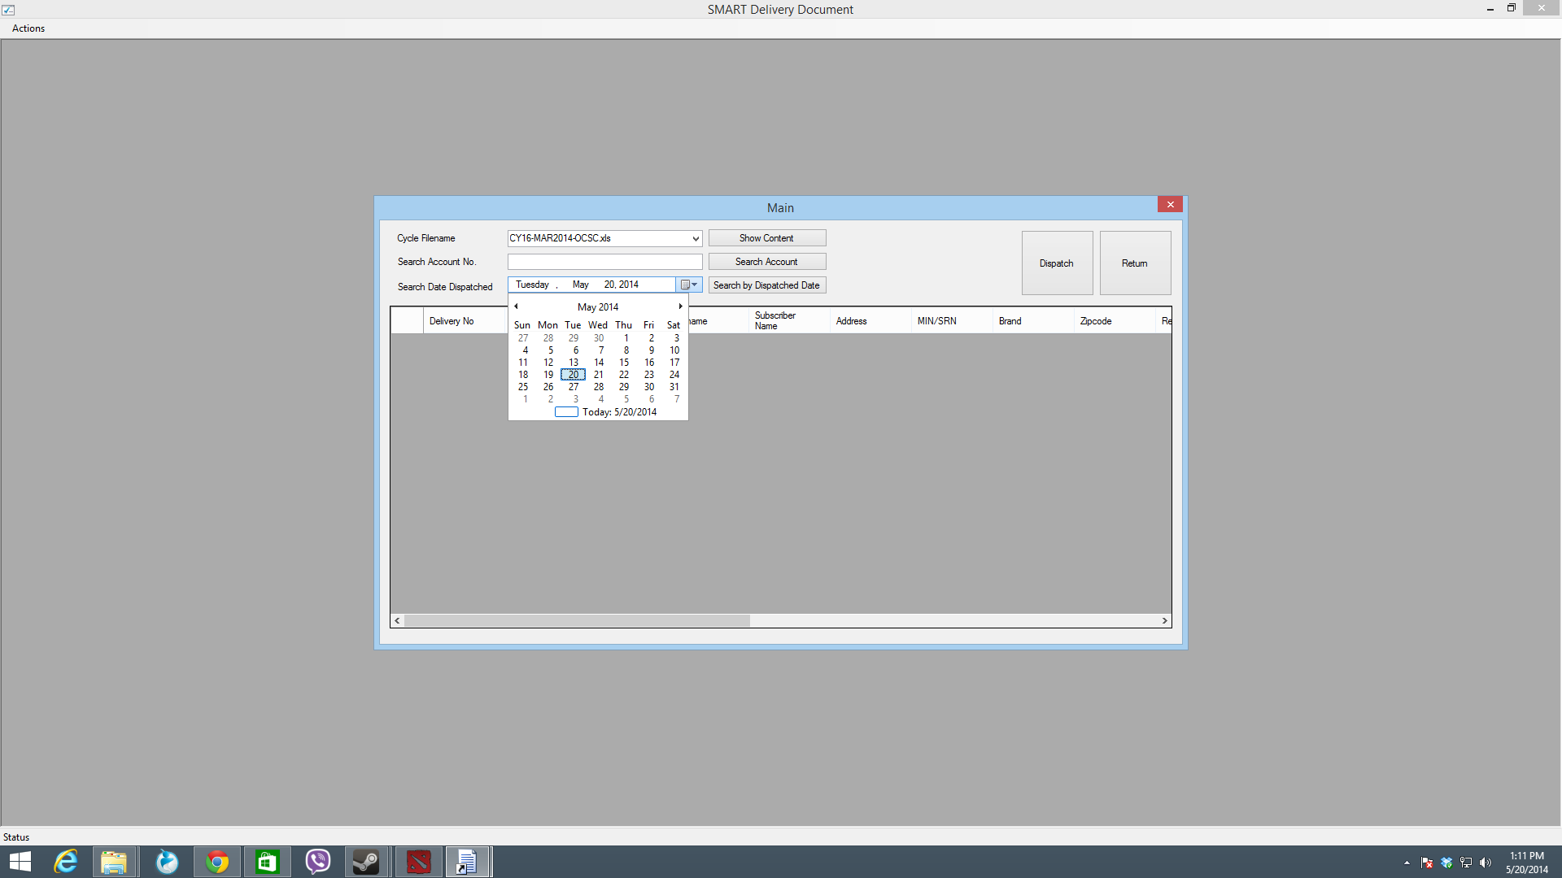

1. **Dispatching a Delivery Document**

To dispatch a delivery document to a particular account, press the **Dispatch** button from the main screen. This is brings up a small window (form) for dispatching documents as shown below:

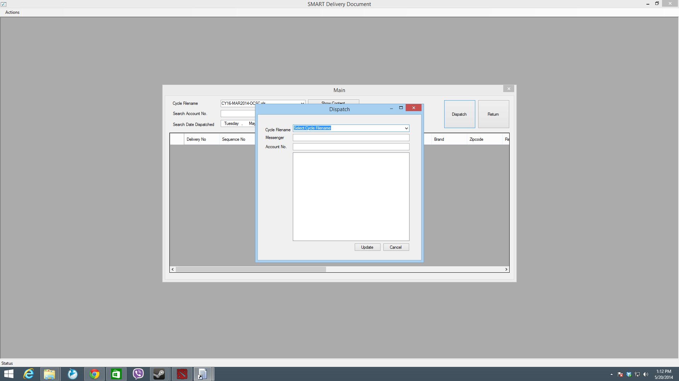

To begin with, you need to follow the steps below:

1. **Select a Cycle filename**

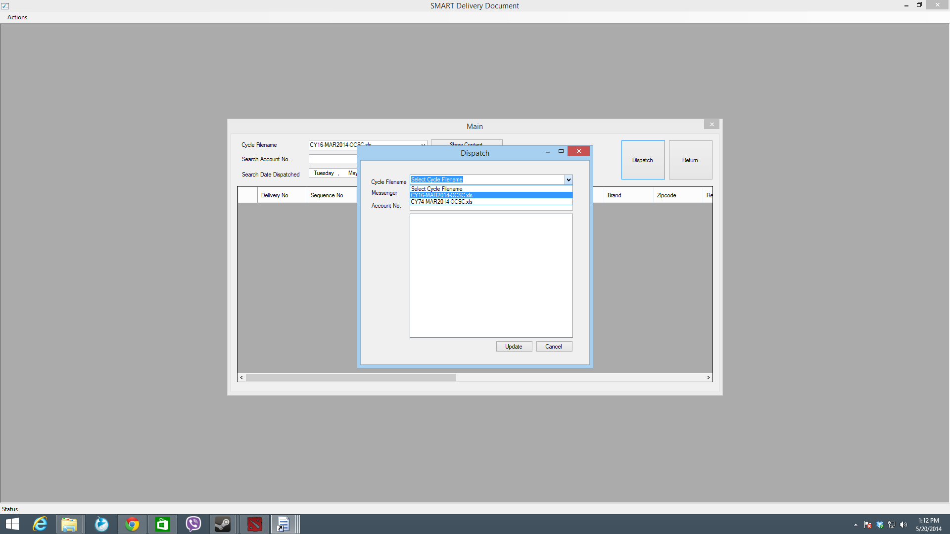

1. **Key-in the Messenger’s name**

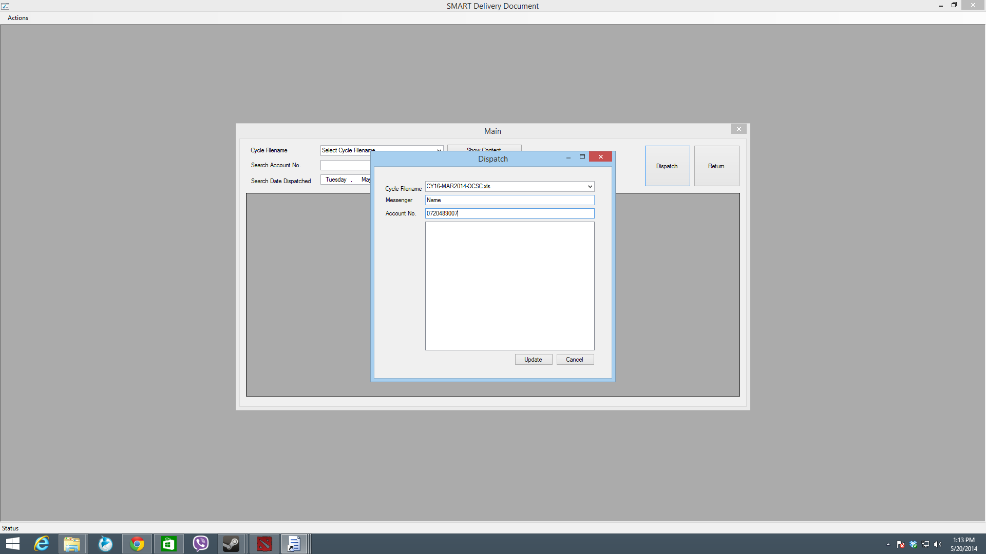

1. **Add Account Numbers to be dispatched with the delivery documents.**

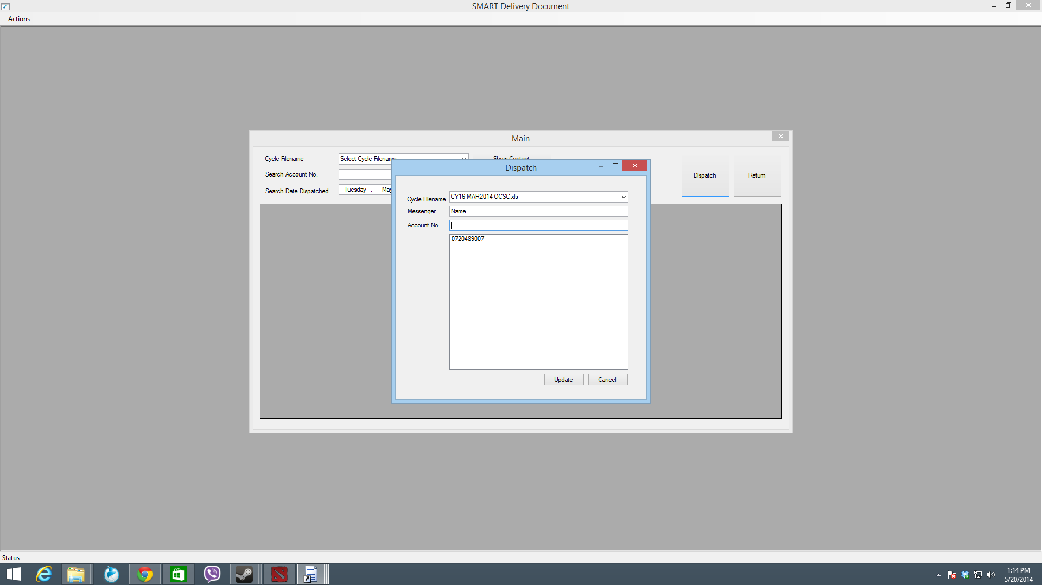

To add Account number, simply type in the Account number in the Account No. text field. **PRESS ENTER.** This should add the typed Account No. to the list just below the Account No text field.

1. **Update**

Update the inputted Account Numbers, by pressing the **Update** button.



When you press the update button, you will a notification that the number of inputted account numbers have been dispatched with the messenger. Image below show the alert after having pressed the **Update** button:

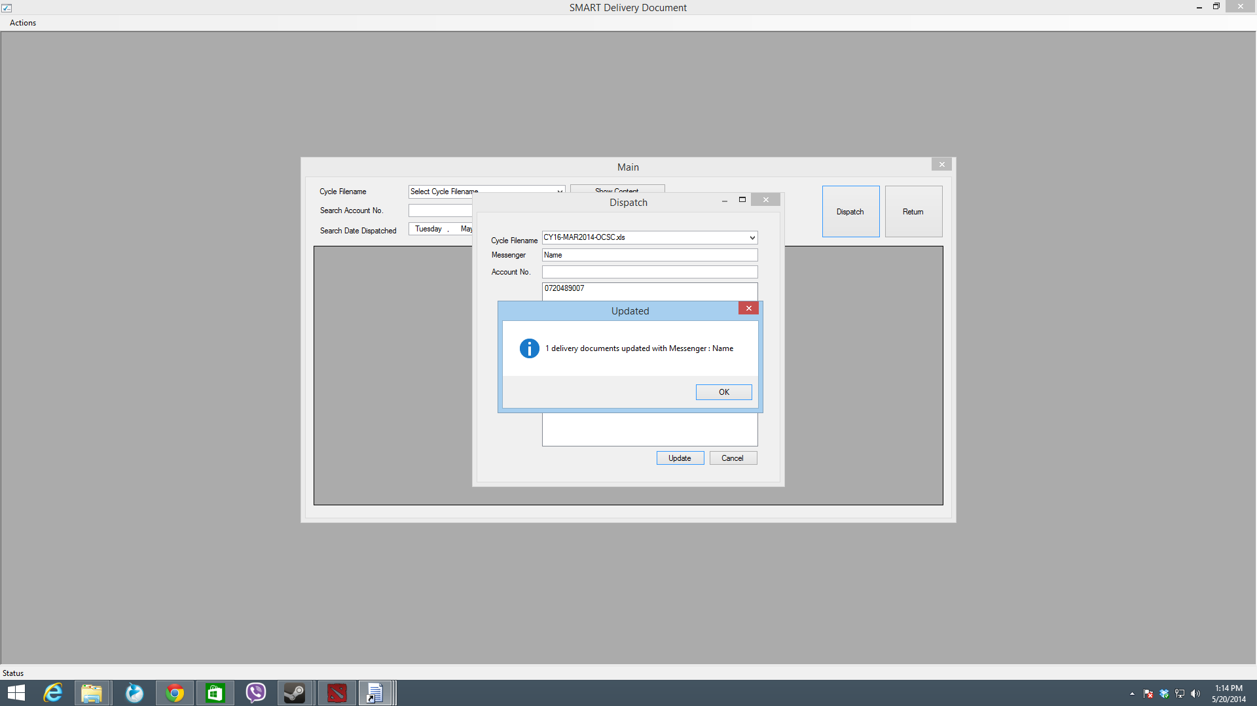

1. **Returning Delivery Document (by Account No.)**

From the main menu, press the **Return** button. This brings up the window for the return of the delivery documents:

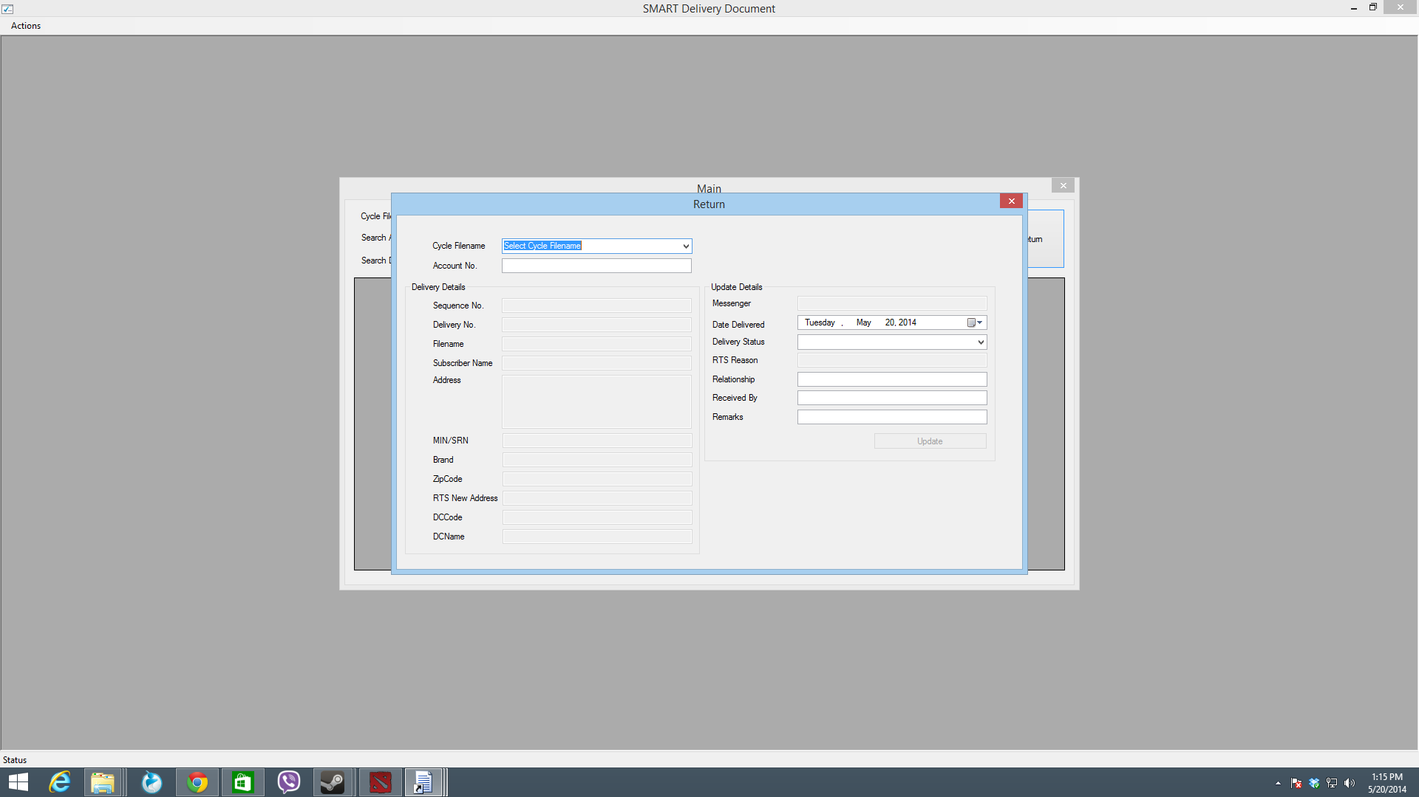

This window allows you to update the returning delivery documents by account number. You will need to select the cycle filename and key-in the account number. The sequence of images below shows the process:

1. Select the Cycle Filename

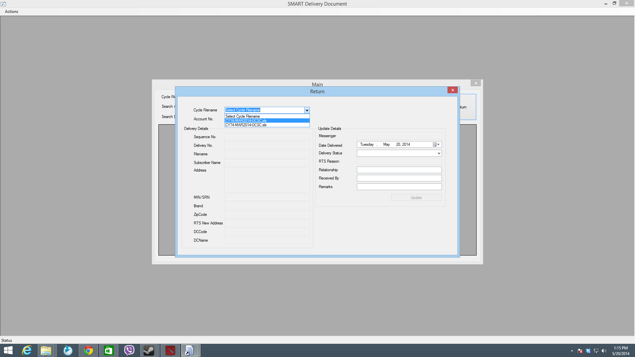

1. Key-in the Account Number

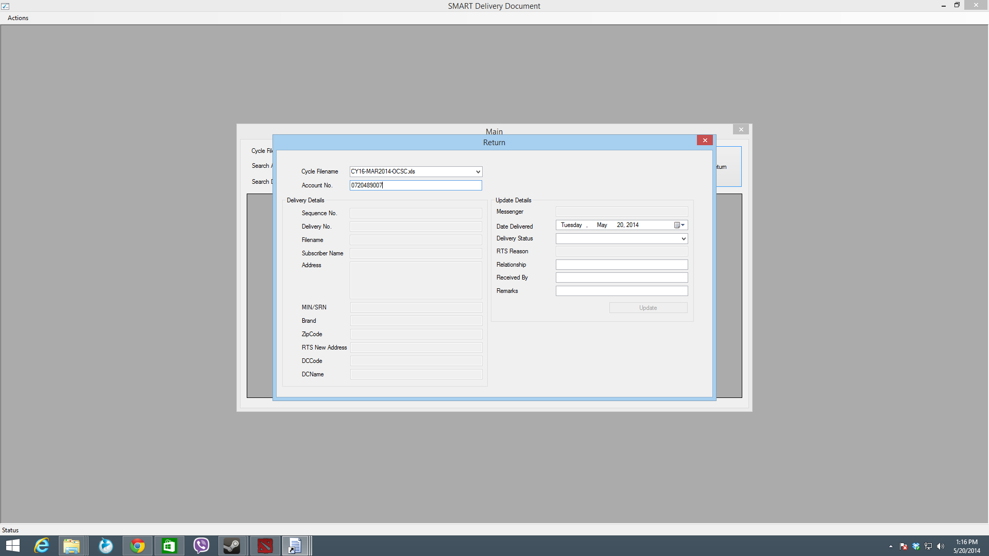

1. **PRESS ENTER**

When the ENTER key is pressed after typed the account number, it fetches the record from the cycle filename using the account number. The details are populated right away to the text field in the form. Then, focus of the cursor is set to the **Delivery Status** field.

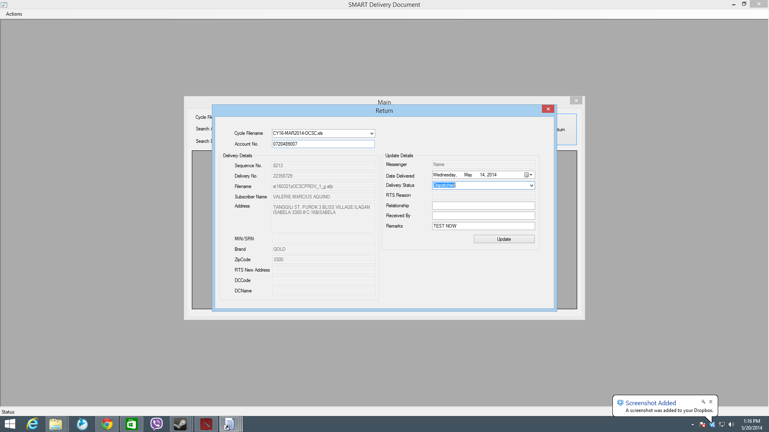

Choose the appropriate status from the combo box as shown below:

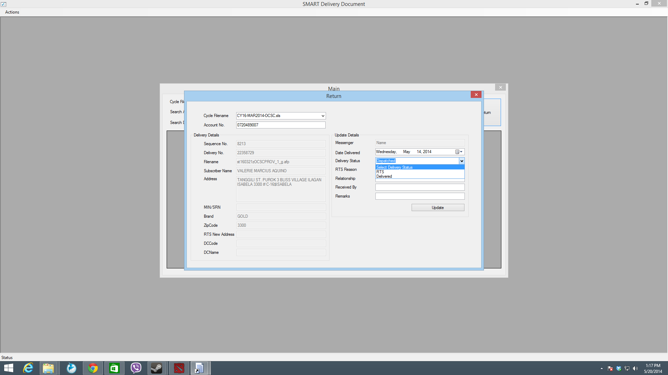

If the selected delivery status is RTS, the RTS Reason field will be enabled, prompting you to type in the reason why the delivery document has been returned to sender.

Then, key-in (type) the relationship to the Relationship text field. If the Relationship “**OWNER”,** then it automatically populates the **Received By** text field by the subscriber’s name. Below shows that the subscriber name (found at the left pane) is the same as the received by field (found at the right pane):

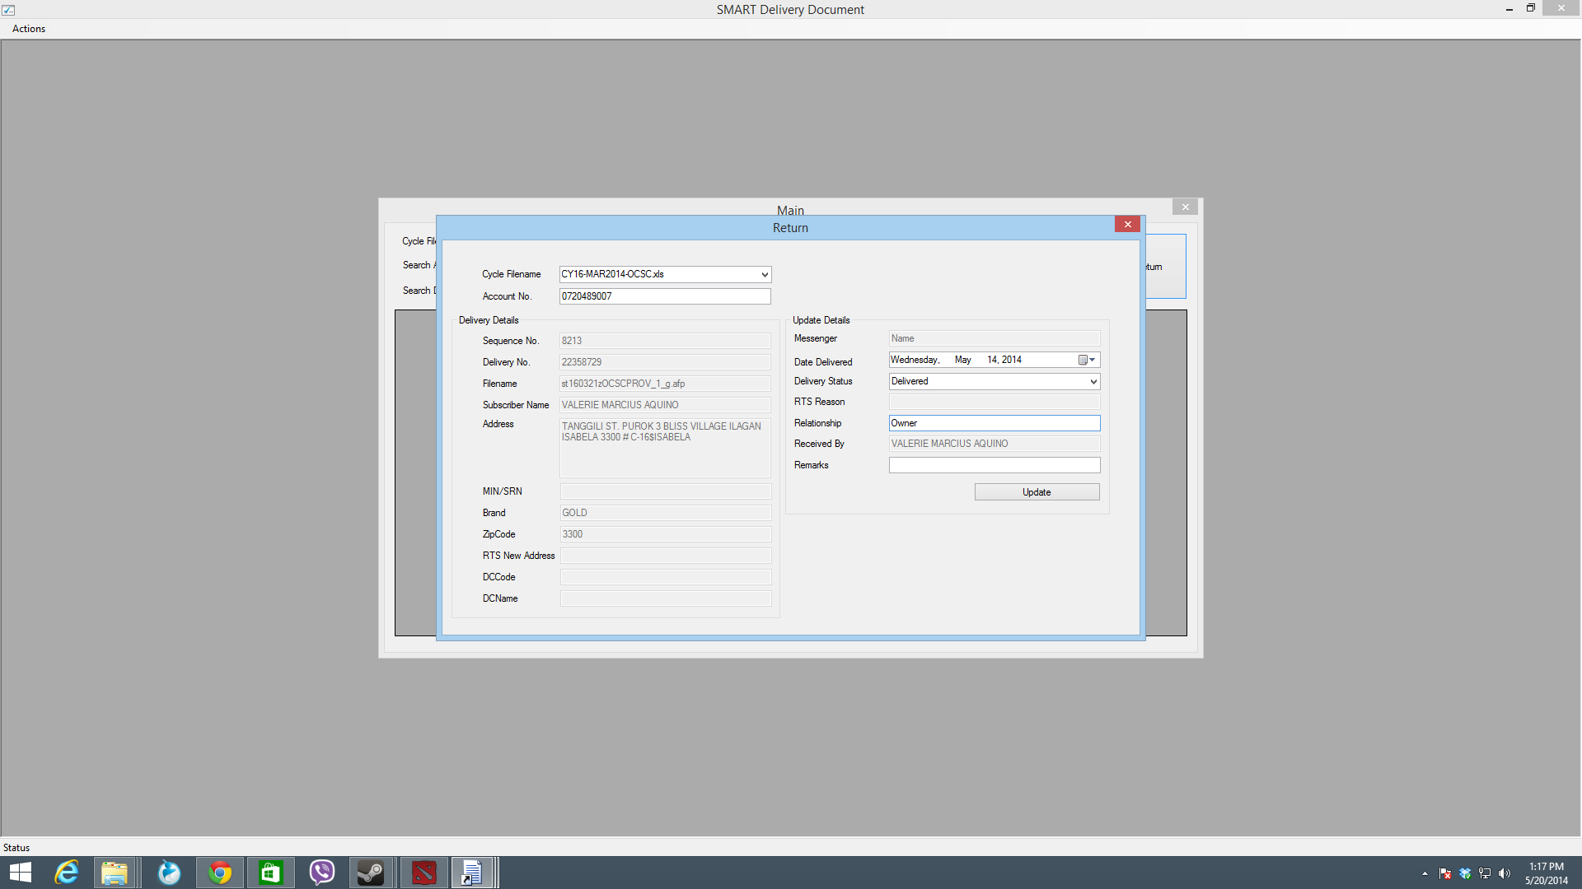

Lastly, press the **Update** button. This will save/store the changes made from the Return form. Image below shows an alert that the details were updated:

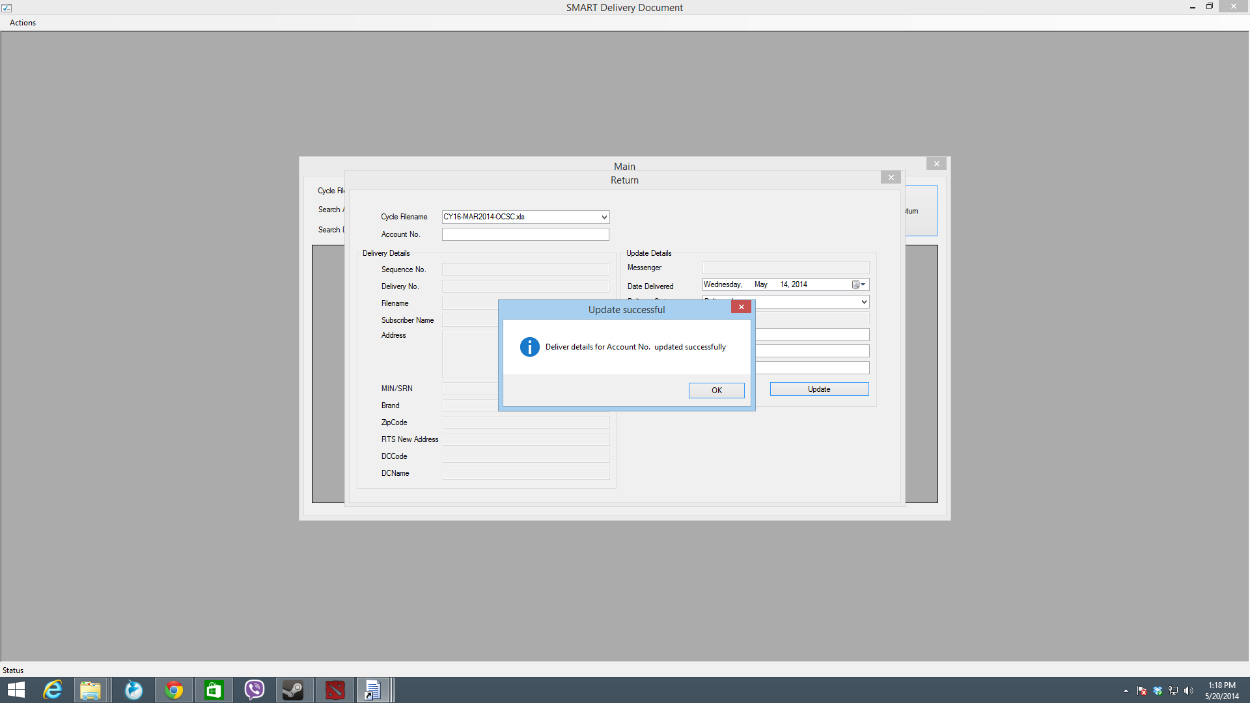

1. Processes start all over again for SEARCHING, DISPATCHING and RETURNING a delivery document. There are no extractions needed, as the cycle filename is directly updated by the application. **END.**